Jason De Leon

00305640

Server setup cont.

Ubuntu

Ubuntu Repository:

Command is: (***apt-cache policy)***

How to install a PPA: Here I install Firefox PPA which can be found on their website or a simple google search. Please be aware that PPA aren’t 100% secured some might be fake PPAs.

Command was ***“sudo add-apt-repository ppa:mozillateam/firefox-next”***

To find all added PPA this the command that will take you to where they’re stored.

***“ls /etc/apt/sources.list.d”***



Part 2: Installing TMUX and Fail2Ban

Command is the following: ***(sudo apt install tmux) (sudo apt install Fail2Ban) (sudo apt install emacs)***

If you want to run Tmux just type in the command (tmux)



Now you want to leave the application you have to hit the following:

Ctrl + B and X right after

This will give you the opportunity to close the application just type “Y” and you’ll be out.



Please note that the command will ask for your admin password.

Fail2Ban:

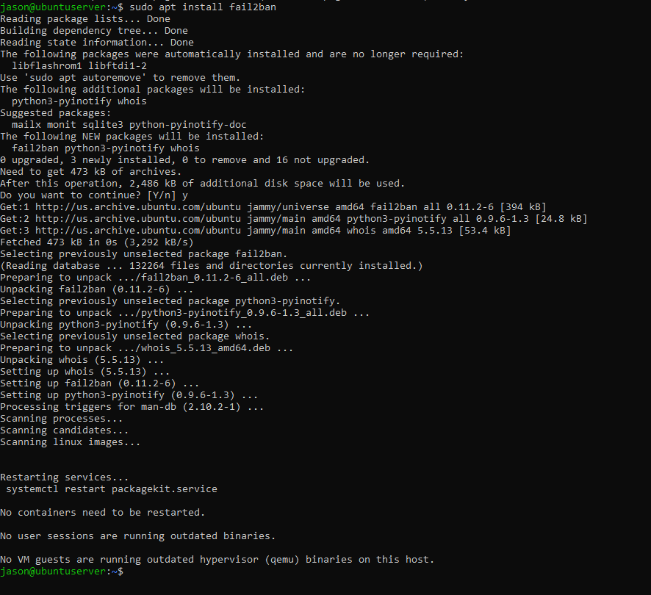

If you’re able to check the service is running or not with the following command: (systemctl status fail2ban)

Then that means you’ve installed it successfully.

Unlike other programs this doesn’t have a simple method of running it. If you type: (cd /etc/fail2ban)

But you can modify the .conf files by using (vi jail.conf)

These are the settings for “fail2ban.conf”

I haven’t modified anything since the initial install, but these were my settings.

Please be aware that it’s recommended to make copies of these .conf files if you plan on making any changes. To do that we would need to type the following

“***sudo cp /etc/fail2ban/jail.conf /etc/fail2ban/jail.local***”

“***sudo cp /etc/fail2ban/fail2ban.conf /etc/fail2ban/fail2ban.local***”

And this is for jail.conf:

Emacs:

(emacs will take a bit longer than the rest of the other installs)

The install will ask you if you want to install the software please hit “y” and enter to continue with the installation.

To run Emacs just type on the command line the following (emacs) You know you’ve done it correctly when you get this screen:

To exit just press the following key together: Ctrl + X



Installing Cowsay:

Command: (sudo apt install cowsay)

You can run cowsay with this command (cowsay -e @@ {anything you want it to say})

Installing Lolcat

Command: (sudo apt install lolcat)

Note: just like emacs this takes a bit of time to install.

The install will ask you if you want to install the software please hit “y” and enter to continue with the installation.

You know you’ve installed it correctly when you do this command: lolcat -h

It tells you the steps and guides on how to use it.

To update your server, you will need to do the following command:

(sudo apt update)

To update your packages and other things please type this command:

(sudo apt upgrade)

Please type “Y” and enter to continue with the updates.

This command will take the longest out of all of them and while prompt you with a second GUI screen. You can simply hit enter. This will reset your services with should be fine to do.

Part 5. I haven’t updated anything or installed anything since the first time I did the setup. Only updates/upgrades happened during this assignment.